understanding dementia

WHEN

28th February 2018

09.30 – 16.00

Where

united reformed church

eden street

kingston

kt1 1hz

TO BOOK

Contact: Bob Hall

Call 07514 093616
Email training@surreyilc.org.uk

https://www.eventbrite.co.uk/e/free-training-dementia-awareness-health-social-care-tickets-37730351497

This event has been organised for
Kingston Centre for Independent Living

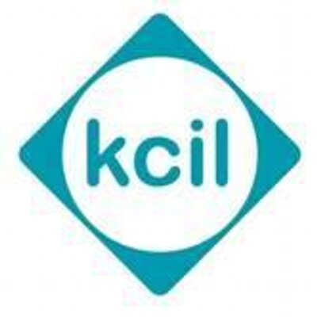

COST - FREE
Assistance with travel costs up to £10.00

LEARN

FREE TRAINING - UNDERSTANDING DEMENTIA.

The word 'dementia' describes a set of symptoms that can include memory loss and difficulties with thinking, problem-solving or language.

This 1 day course will help you to understand:

the different types of dementia and the key characteristics of each

the different areas of the brain and how dementia affects these areas

some common signs and symptoms of dementia

some common myths and negative attitudes about dementia

some of the complex difficulties people with dementia

This is a FREE COURSE

You will receive a certificate.

We can pay your travel costs up to £10.00

Secure your place today!

