health and SAFETY

WHEN

27th February 2018

09.30– 13.00

Where

united reformed church

eden street

kingston

kt1 1hz

TO BOOK

Contact: Bob Hall

Call 07514 093616
Email training@surreyilc.org.uk

https://www.eventbrite.co.uk/e/free-training-health-safety-in-health-social-care-tickets-37723472923

This event has been organised for
Kingston Centre for Independent Living

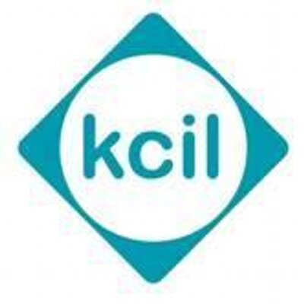

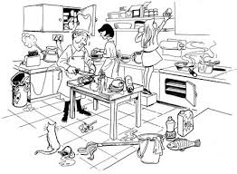

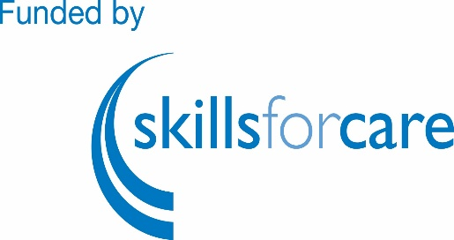

COST - FREE
Assistance with travel costs up to £10.00

LEARN

FREE TRAINING - this half day course is for Personal care Assistants (PAs) Individual Employers(IEs) and their Carers

You will learn:

what common hazards there are around the home

how to work to minimise the risk of accident or injury

why it is important to work in ways agreed by/with your employer

how to promote personal safety:

It covers e.g.:

Slips trips and falls

COSHH

equipment and electrical safety, fire safety.........and much more

This is a FREE COURSE

You will receive a certificate.

We can pay your travel costs up to £10.00

Secure your place today!

