Medication awareness

WHEN

27th February 2018

13.30– 17.00

Where

uNITED REFORMED CHURCH

EDEN STREET

KINGSTON

KT1 1HZ

TO BOOK

Contact: Bob Hall

Call 07514 093616
Email training@surreyilc.org.uk

https://www.eventbrite.co.uk/e/free-training-medication-health-social-care-tickets-37729094738

This event has been organised for
Kingston Centre for Independent Living

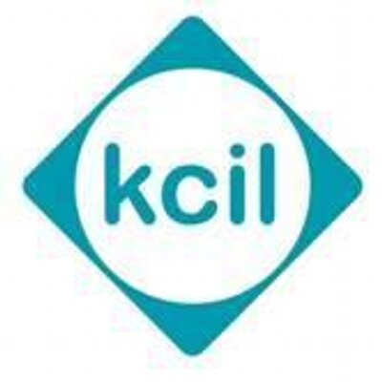

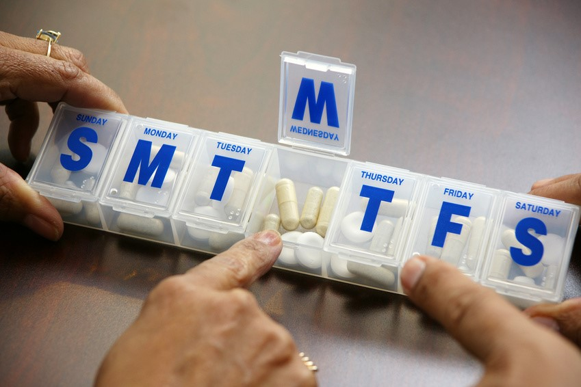

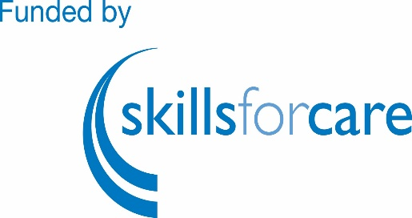

COST - FREE
Assistance with travel costs up to £10.00

LEARN

FREE TRAINING - this half day course is for Personal care Assistants (PAs) Individual Employers(IEs) and their Carers

You will learn:

key legislation

the different types of medication

your responsibilities

what to do if a mistake is made

....and much more

This is a FREE COURSE

You will receive a certificate.

We can pay your travel costs up to £10.00

Secure your place today!

