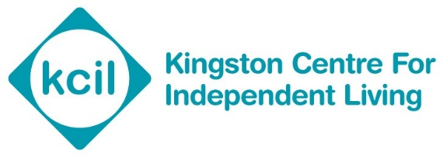
NAME
Personal budget plan

Forename:  Family name: | Telephone Numbers:  Mobile:
Date of birth: | Email:
Address:  Postcode: | Name of current school:
Next of kin/contact name and address: | Relationship of person being supported:
Assessed need:
I agree that my plan may be shared as needed to enable me to receive the support and services requested (please circle opposite):  (If patient lacks capacity, representative to make decision) | Yes | Yes but with restrictions | No

about me

The PB Objective

Need | Outcome | Output

Weekly timetable
.

Monday | Tuesday | Wednesday | Thursday | Friday | Saturday | Sunday
 | 15.30-20.30 |  | 15.30-20.30 |  | 10.00-18.00

Setup SMART
The following table will outline the setup process, each stage and how this will be achieved

SMART goal | What needs to happen | By when | By whom | Contact details

Costing
PA hours | Price
Total number of hours
NIC/tax-max 13.8%
Holiday entitlement
Additional costs
Contingency budget
Total

Contingency
The contingency will outline the processes in place for when the provision does not go according to plan. The allocated contingency budget is…

Circumstance | Action to be taken | Individual responsible

