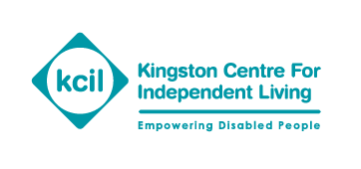

Notice of Annual General Meeting (AGM) and 50th Year Celebration

You are cordially invited to KCIL’s Annual General Meeting and 50th year Celebration.

When: Thursday, 22nd November 2018 from 11am-1:00pm

Where: Holiday Inn Kingston South, Portsmouth Road, Surbiton, Surrey KT6 5QQ

The AGM will give you the opportunity to hear what the organisation has been doing over the past year and to take part in a discussion about the challenges and opportunities KCIL faces in the future. It will also be an opportunity for you to meet our Trustees.

There will be a presentation by Jen Kavanagh about the Fighting For Our Rights project we ran last year, which covers a lot of KCIL’s 50 years history.

The key note speaker is RBK Councillor, Margaret Thompson, who is the Portfolio Holder for Adult Social Care. There will be an opportunity to ask her questions.

Copies of the Annual Report and Financial Statements for the year ending 31 March 2018 will be available nearer the day. Could you please notify me either by phone: 020 8546 9603 or email: robert.reilly@kcil.org.uk if you require the Annual Report in large print or other accessible format.

Following the AGM, there will be an opportunity for you to join us and network at a lunch in the hotel.

Please R.S.V.P. by 9th November using the enclosed booking form.

Charity No 1123063 