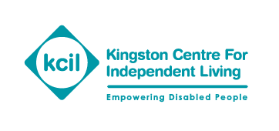
River Reach
31-35 High Street
Kingston KT1 1LF
Telephone: 020 8546 9603
Email: enquiries@kcil.org.uk
Website: kcil.org.uk

Direct Payments - Advice notes

Holiday pay

Entitlement
Your Personal Assistant (PA) is legally entitled to 5.6 weeks paid holiday (including bank holidays) each year, or in proportion if they work part time.
You can work out your PA’s exact entitlement by multiplying the number of hours or days they work for you each week by 5.6 weeks to get a total. For example, if they work 5 hours every week: 5 x 5.6 = 28 hours a year. If they work 3 days a week: 3 x 5.6 = 17 days a year.
If your PA works irregular hours you will need to use the online calculator to work out how much leave they are entitled to. This can be found at: www.gov.uk/calculate-your-holiday-entitlement.
If your PA does not work set hours, please contact us for more information and advice.
Your PA’s leave year should be set out in the employment contract.
When a PA starts to work for you, they will have to build up annual leave, especially in the first year. This means they will have to work a certain amount of time before they can have a day off.
Your PA should take all their leave within the leave year.
Self-employed
If your PA is self-employed, they are not entitled to a paid holiday.

Rolled up holiday pay

Rolled up holiday pay is unlawful. This is where an employer includes the basic hourly rate (£9.75) with the holiday pay amount (£1.17) to increase the PA’s hourly rate to £10.92.
Government guidance states:
"Holiday pay should be paid for the time when annual leave is taken. An employer cannot include an amount for holiday pay in the hourly rate (known as 'rolled-up holiday pay'). If a current contract still includes rolled-up pay, it needs to be re-negotiated."
www.gov.uk/holiday-entitlement-rights/holiday-pay-the-basics
More information and help
If you need help to understand this advice note, or you’re not sure or worried about something, please get in touch with us and we’ll be happy to help.
Publication date: October 2022
Review date: October 2023

