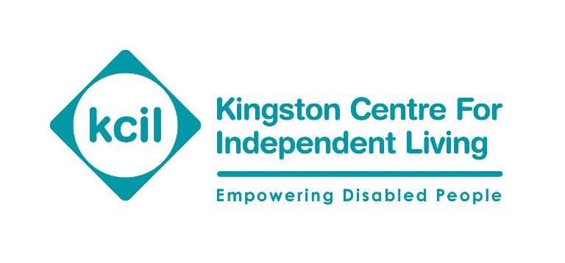
River Reach
31-35 High Street
Kingston KT1 1LF
Telephone: 020 8546 9603
Email: enquiries@kcil.org.uk
Website: kcil.org.uk

Direct Payments - Advice notes
Employed or self-employed – what difference does it make?
When you take on a Personal Assistant (PA) you will need to work out their ‘employment status’ under employment law and tax law.
This is reasonably straightforward and we at KCIL can help you with this.
A person’s ‘employment status’ relates to whether your PA is an employee of yours or is self-employed.
A person is an employee if they have a contract to work for you, you tell them what to do, how to do it and when.
A person is self-employed if they are their own boss, run their business for themselves and take responsibility for its success or failure.
This difference is important because each employment status has different rights and responsibilities and so you will have too.
Tax law and employment status
Tax employment status is important as it affects the type and rate of Tax and National Insurance Contributions (NICs) a person pays.
You cannot just pick a tax employment status because it is better for you or your PA. Tax law can dictate your PA’s Tax Employment Status.
Should you get the status wrong, you could find that you have to pay any unpaid Tax and NICs to Her Majesty’s Revenue and Customs (HMRC) and, in some instances, a penalty charge too.
If you take on a PA who is genuinely self-employed, you will not have the responsibility of deducting Tax and NICs from their wages as this will be their responsibility.
If you use an agency, they are the employers so you do not need to do anything.
If your PA is employed by you, it’s your responsibility to deduct Tax and NICs from their wages. If you join KCIL’s payroll service for free this will be done for you so you won’t have to worry about it.

Deciding if your PA is employed or self-employed
Self-employed workers will be registered with HMRC so you could ask them for a copy of their registration letter.
In most cases it is generally straightforward to decide someone’s tax employment status.
If the answer is 'Yes' to all or most of the following questions, then your PA is probably an employee:
- Do you tell them what work to do as well as how and when to do it?
- Do they have to do the work themselves?
- Can you move them from task to task?
- Are they contracted to work a set number of hours?
- Do they get regular pay or a salary, even if there is no work available?
- Can they get overtime pay or bonus pay?
- Do they get benefits such as paid leave or a pension as part of their contract?
If the answer is 'Yes' to all or most of the following questions, it will usually mean that your PA is self-employed:
- Can they hire someone else to do the work for them or engage helpers at their own expense?
- Do they decide what work is done, when and where or how it is done?
- Do they risk their own money?
- Do they provide the main items of equipment they need to do their job, not just the small tools that many employees provide for themselves?
- Do they agree to do a job for a fixed price regardless of how long it takes to finish the job?
- Do they use their own money to buy business assets, pay for running costs and so on?
- Can they make a loss or a profit?
If you have any doubts, HMRC can help you decide the tax employment status of your PA.
They offer an online tool which you can use to help you:
www.gov.uk/guidance/check-employment-status-for-tax
HMRC says you can rely on the tool answer as evidence of your PA’s status for Tax and NIC purposes providing you answered the questions accurately. You should print or save a copy of the enquiry and result so that if there are any questions from HMRC at a later date you can show these as evidence that you ran a tax employment status check.
You can also contact the HMRC customer service team to ask for a written opinion about your situation:
www.gov.uk/government/organisations/hm-revenue-customs/contact/status-customerservice-team
Tel: 0300 123 2326
Employment law and employment status
Under employment law employees and self-employed workers have different rights. There is also the employment status of ‘worker’ which are those people who typically have ‘casual’, ‘freelance’, or ‘zero hours’, contracts. However, here we are mainly looking at the differences between employees/workers and self-employed PAs.
Employee rights
All employees are workers, but an employee has extra employment rights and responsibilities that don’t apply to workers.
Worker’s rights include:
- Getting the National Minimum Wage
- Protection against unlawful deductions from wages
- The statutory minimum level of paid holiday
- The statutory minimum length of rest breaks
- To not work more than 48 hours on average per week or to opt out of this right if they choose
- Protection against unlawful discrimination
- Protection for ‘whistleblowing’ - reporting wrongdoing in the workplace
- To not be treated less favourably if they work part-time
Employee rights include all worker’s rights but also the following rights:
- Statutory Sick Pay
- Statutory maternity, paternity, adoption and shared parental leave and pay (workers only get pay, not leave)
- Minimum notice periods if their employment will be ending, for example if an employer is dismissing them
- Protection against unfair dismissal
- The right to request flexible working
- Time off for emergencies
- Statutory Redundancy Pay

Self-employed PAs rights and responsibilities
The genuinely self-employed are not covered by employment law because they are their own boss, and so do not have the rights of an employee/worker as listed above. They are also responsible for paying their own tax and NICs. However, if a person is self-employed:
- they still have protection for their health and safety and, in some cases, protection against discrimination
- their rights and responsibilities are set out by the terms of the contract they have with their client
More information and help
If you need help to understand this advice note, or you’re not sure or worried about something, please get in touch with us and we’ll be happy to help.
Publication date: October 2022
Review date: October 2023

