YOU HAVE A RIGHT to complain if you are not satisfied with the service provided by KCIL.

TO MAKE A COMPLAINT Supply the details requested on this form to the KCIL office. Alternatively, you may telephone the Chief Executive Officer.

WHO TO COMPLAIN TO Your complaint should be forwarded to KCIL’s Chief Executive Officer.

WHAT WILL HAPPEN TO MY COMPLAINT?
You will receive an acknowledgement within 4 working days and a full response within 3 working weeks of your complaint having been received.

IF YOU ARE NOT SATISFIED with the response from the Chief Executive Officer, you can forward your complaint to KCIL’s Chairperson. The Chairperson will respond within 3 working weeks of your complaint being received. If you are still unhappy with the response, you can request that the complaint be referred to the Board of Directors. The Board of Directors will then appoint a panel to deal with the matter. The Board of Directors will decide the terms of reference for the panel and the decision of the panel will be final.

IT’S NOT ALL BAD Do feel free to feed back positive comments, too.

COMMENTS AND COMPLAINTS FORM

Are you dissatisfied with KCIL, or do you have a comment or suggestion to make?

If you are dissatisfied with the service that you have received from KCIL, please complete the form below.

Alternatively, you may have a good idea you would like to see us develop further. Please use this form to make your views known to us.
Your name:

Your address:

Tel. No.

E-mail:

Please give the date and time of the incident you wish to complain about

WHAT IS YOUR COMMENT OR COMPLAINT
What is your comment or complaint? (You may need to continue on a separate sheet)

What do you think KCIL should have done to be more helpful? Or, what do you feel we should be doing?

Please return this form to the address opposite; we will contact you as soon as possible. This form is available in large print.

Remember, you may wish to contact the Chief Executive
Officer by telephone, if that would be easier, on 020 8546 9603. If you need support with the form or need it in other formats, please contact the main office on 020 8546 9603.
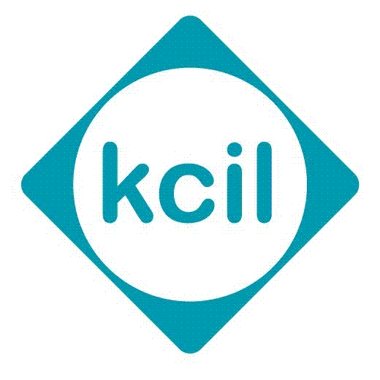

- COMMENTS & COMPLAINTS -

If you have comments or a complaint
about KCIL, please let us know

Kingston Centre for
Independent Living

River Reach
31-35 High Street
Kingston upon Thames
Surrey KT1 1LF

Tel: 020 8546 9603
Email: enquiries@kcil.org.uk

