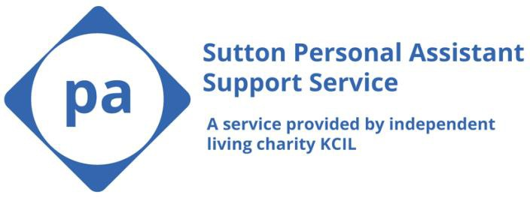
Sutton Personal Assistant Support Service Recruitment REFERRAL FORM
Please complete this form and return to suttonpa@kcil.org.uk or to the postal address at the end of this form:

For support completing the form or to request the form in an alternative format, please call 020 8546 9603.

Personal details:

Full name
Address
Email
Phone number
Preferred contact method
Date of birth

Personal Assistant (PA) requirements:

I would like a PA that will support myself/my family member/my friend with the following activities: | Activities:
I would like the PA to work at the following times: | Day(s):  Time(s):
I require the PA to have the following skills/training: | Skills/training:

Further information I would like to add:

Next of kin details (if relevant):

Name of Parent/Carer/Next of Kin:
Email address:
Phone number:
Relationship to service user:

Referrer details:

Referred by: | ☐Adult Social Care  ☐Encompass  ☐Self-Referral
Key workers name:
Referral date:
Phone number:
Email:

Consent:

The Sutton Personal Assistant Support Service is carried out by a south-west London based charity called KCIL (Pronounced K-CIL )

As part of the Sutton Personal Assistant Support service and to be able to support you effectively we may be required to share information with other organisations, and they may share your information with us. Please sign below to confirm that you have read through the following statements.

- I/parent/carer give consent to KCIL to work in the Sutton Personal Assistant Support Service and may share information about me/ or my carers, when relevant, with Social Care, Education and Health Providers. For example, Sutton Council, Sutton Encompass, Sutton Adult Social Care.
- Under the Care Act 2014 KCIL are required to share my information with relevant parties if they feel that it is in my vital interests or another person/s.

- I/parent/carer understand that KCIL can use my personal data on the basis of this agreement and at any time I can withdraw my consent and they will stop using it.

- I/parent/carer give permission to KCIL to hold data about me. KCIL will comply with the legal requirements in relation to the storage and use of personal data as stipulated in the UK by the Data Protection Act (2018) and any subsequent similar acts. KCIL's privacy policy can be found at https://kcil.org.uk/wp-content/uploads/2021/04/KCIL-privacy-policy.pdf. Please contact enquiries@kcil.org.uk if you wish to withdraw consent or to find out what data KCIL has on you.
KCIL seeks to ensure that all people across South West London, live as independently as they choose. We will provide you with news, events and information from KCIL about the work that we do. If you are interested in becoming a member of KCIL and the additional support we provide, please email enquiries@kcil.org.uk.

Signed:…………………………………………Date…………………………………………………………..

Sutton Personal Assistant Support Service
KCIL
River Reach, 31-35 High Street,
Kingston upon Thames,
KT1 1LF

