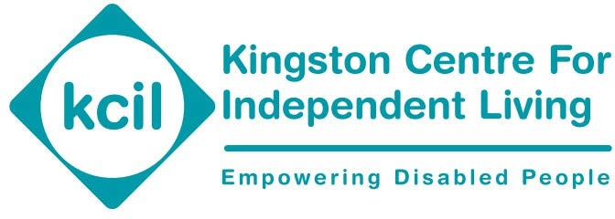

Kingston Centre for Independent Living (KCIL) GDPR and Information Governance notice

KCIL is committed to ensuring that all personal data is processed lawfully, transparently and securely in accordance with the Data Protection Act 2018 and UK General Data Protection Regulation (UK GDPR).

We recognise that, as a provider of commissioned services, we handle sensitive personal data including health, financial and safeguarding information. We therefore maintain robust information governance arrangements to ensure data is protected at all times.

KCIL will hold and process all information concerning you as an individual strictly in accordance with its Data Protection and confidentiality policies and the Data Protection Act 2018. Such data will be used by KCIL to administer our relationship with you and to provide you with information about our activities and for related purposes. We will not share personal data with third parties unless this is necessary to deliver our services, required by law, or where there is a safeguarding concern.

It is unlikely, in the course of KCIL's activities, that personal data will be transferred outside of the UK/EU. KCIL will ensure that in circumstances where this would happen, legal safeguards are in place to legitimise transfers of personal data outside the UK/EU. For example, we will ensure that the cloud-based software that KCIL uses in its activities is GDPR compliant.

KCIL maintain records of personal data processing activities and regularly tests, assesses and evaluates the effectiveness of our GDPR procedures.

Information Governance

KCIL has clear accountability for information governance:

- The CEO has overall responsibility for data protection compliance

- Operational responsibility sits with the Operations Manager

- All staff are responsible for handling data securely in line with this policy KCIL ensures that data protection is embedded into all services and processes.

Lawful Basis

KCIL processes personal data under the following lawful bases:

- Consent (where appropriate)

- Contractual necessity (to deliver services)

- Legal obligation

- Vital interests (including safeguarding situations)

- Legitimate interests (where appropriate and balanced against individual rights)

Data Security

KCIL implements appropriate technical and organisational measures to protect personal data, including:
- Secure IT systems with password protection and access controls

- Restricted access to sensitive information on a need-to-know basis

- Secure storage of physical records

- Use of approved systems for storing and processing data

- Regular review of data access and storage practices Information Sharing
Personal data may be shared with partner organisations, including local authorities and safeguarding agencies, where this is necessary to deliver services or protect individuals from harm.

Where there is a safeguarding concern or risk of serious harm, information will be shared without consent in line with legal requirements and statutory guidance.

Data Retention

KCIL retains personal data only for as long as necessary in line with legal, contractual and operational requirements.

Data relating to safeguarding concerns may be retained for longer periods where required for legal or safeguarding purposes.

Data Breaches

KCIL has procedures in place to identify, report and manage personal data breaches.
Any data breach will be assessed and, where required, reported to the Information Commissioner’s Office (ICO) within statutory timeframes.
Training
All staff receive data protection training as part of their induction and ongoing refresher training.
Training is proportionate to role and includes handling sensitive and safeguarding-related data.
Privacy Notices
Further detail on how personal data is used is provided in KCIL’s Privacy Notices, including service-specific notices such as the Personal Assistant Recruitment GDPR Notice.

-

KCIL maintain records of personal data processing activities and regularly tests, assesses and evaluates the effectiveness of our GDPR procedures.

Should you wish to withdraw that consent at any time, or to obtain a description of the data we hold on you, please contact

Joanne Stafferton, Operations and Marketing Manager
Kingston Centre for Independent Living
River Reach,
31 – 35 High Street,
Kingston upon Thames,
KT1 1LF,
020 8546 9603 enquiries@kcil.org.uk

Updated July 2025

